Lab Writeup - Analyzing Linux Auditd Log

- What account was compromised? (2 points)

Answer : btlo
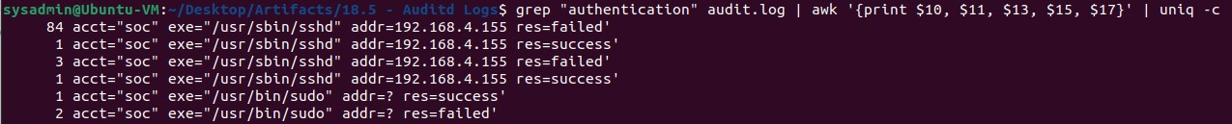There were 84 failed login attempts against account=soc

- What attack type was used to gain initial access?

Answer : Brute Force
There were 84 failed login attempts with the same attacker IP address

- What is the attacker's IP address?



Using command :

sudo aureport -au -if audit.log we also can see this brute force activity

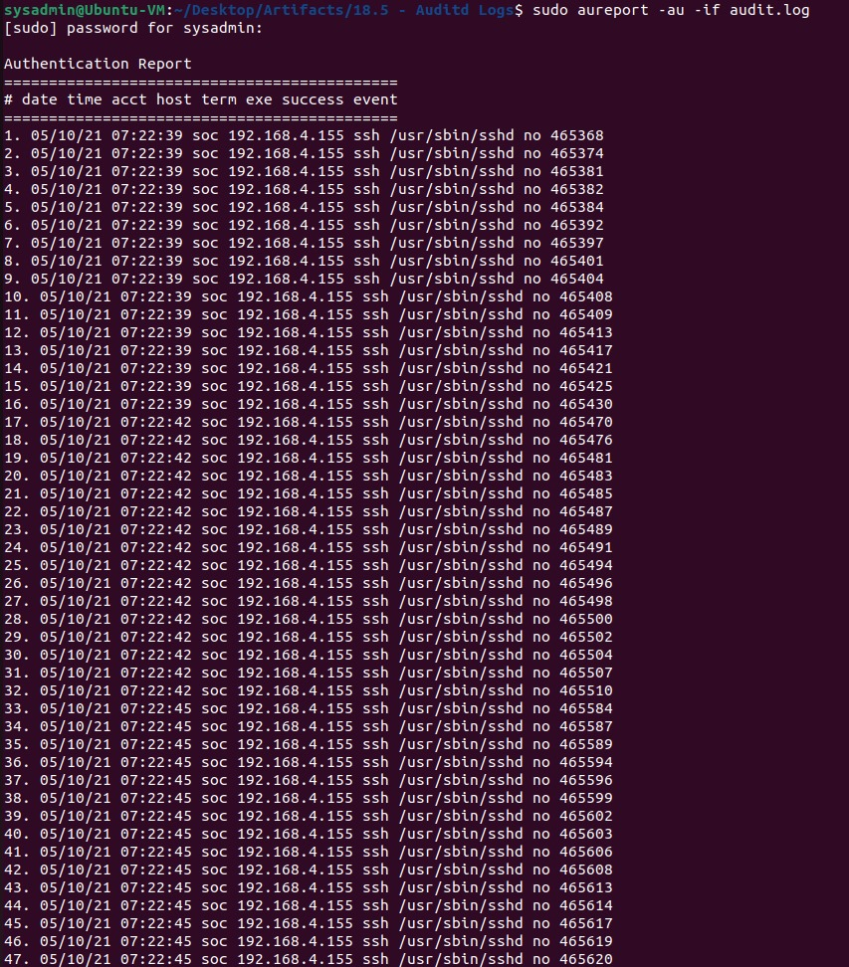

Answer : 192.168.4.155

- What tool was used to perform system enumeration? (2 points)

Answer : linpeas
  - grep “type=EXECVE” audit.log | grep “wget”
-> to see if there is any activity to download malicious files from outside. Checks are also made on other Linux utilities for downloading files such as curl, scp, ftp, etc.
  - or you can also check by using the keyword
“type=EXECVE” and
“192.168.4.155” as the suspected IP address
attacker grep “type=EXECVE” audit.log | grep “192.168.4.155”

We also can see this one using command : sudo aureport --tty -if audit.log
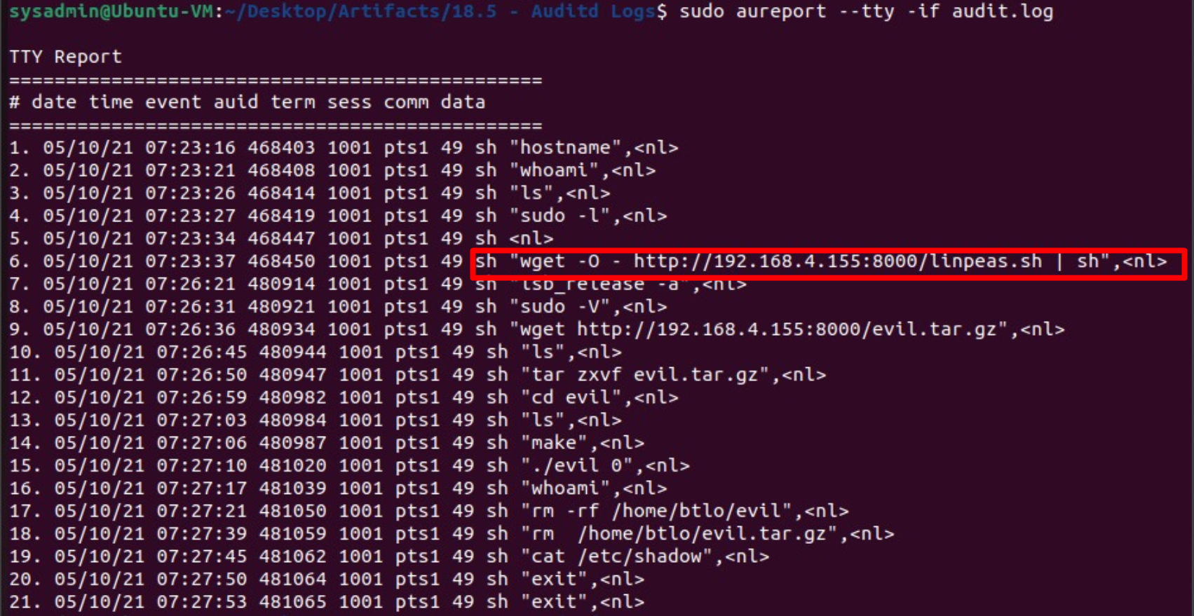

- What is the name of the binary and pid used to gain root? (3 points)

Answer : evil, 829992
  - Grep “type=EXECVE” audit.log, after running the evil binary, there is an execution of the whoami command, possibly the attacker checks whether he has obtained root access or not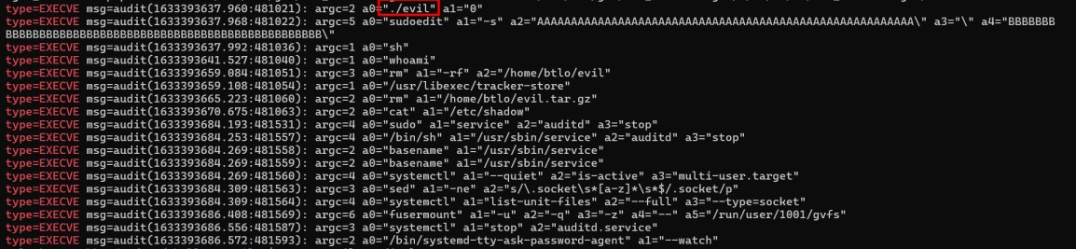
  - grep ".evil" audit.log
  - We also can see this from aureport command
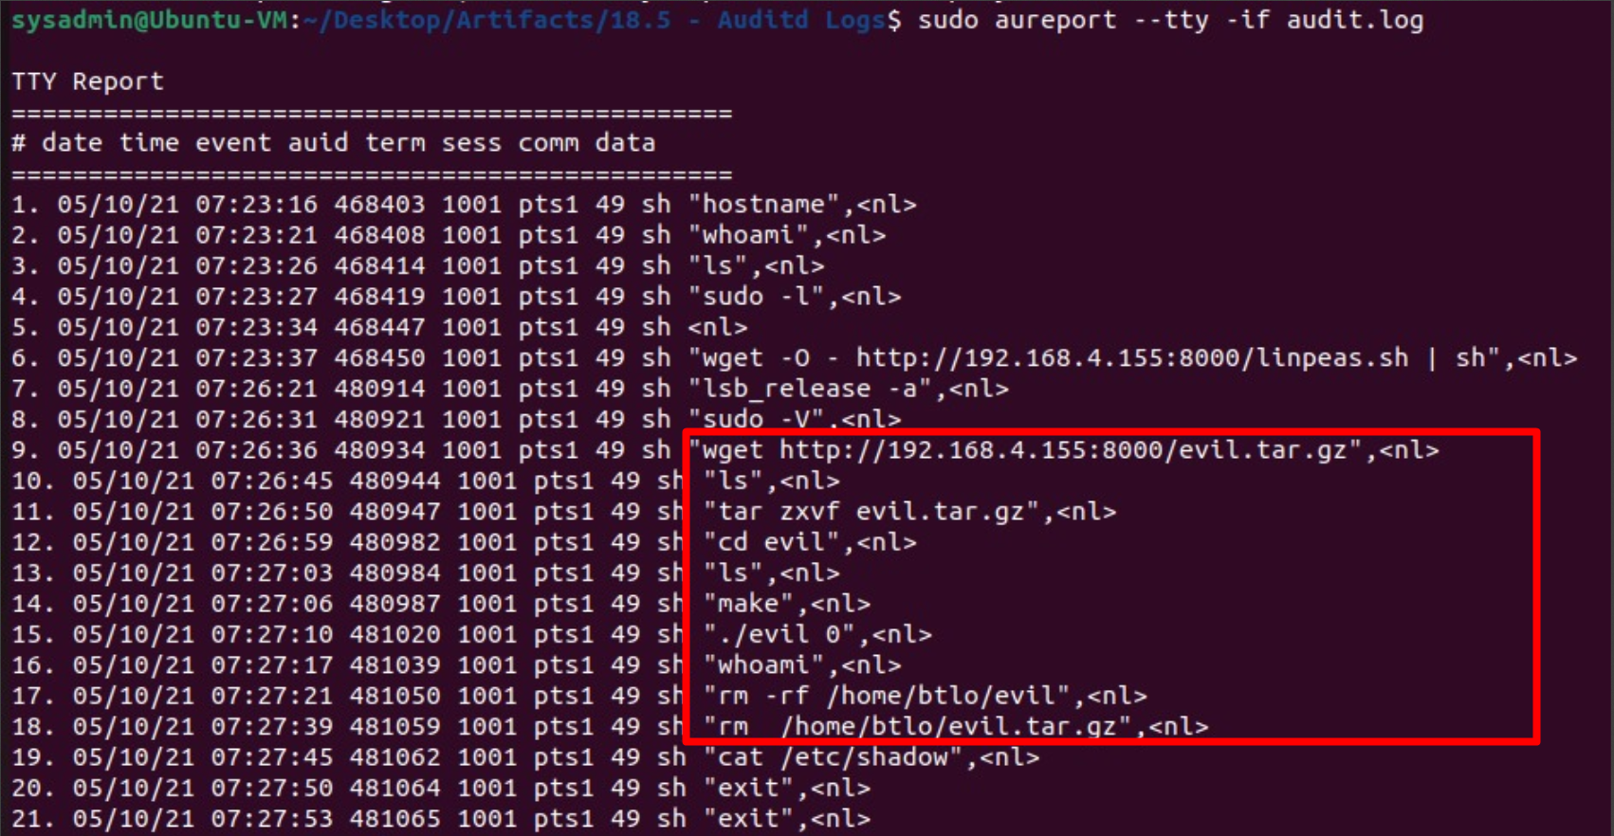

- What CVE was exploited to gain root access? (Do your research!) (3 points)


Answer : CVE-2021-3156

- What type of vulnerability is this? (3 points)

Answer : Heap-Based Buffer Overflow
qualys.com/2021/01/26/cve-2021-3156/baron-samedit-heap-based-overflow-sudo.txt

- What file was exfiltrated once root was gained? (3 points)

Answer : /etc/shadow
  - Grep “type=EXECVE” audit.log
Based on the previous log (the one in the red box), the attacker runs binary evil. After that, it runs the sudoedit command which indicates that the attacker already has privileged root.
